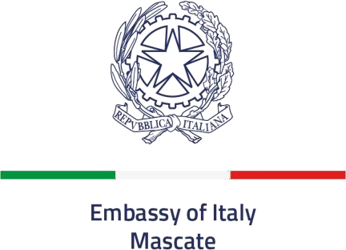

TOURIST VISAS FOR NON OMANI NATIONALS LEGALLY RESIDING IN OMAN
Documents required for Schengen Visa applications

E-Application form – duly completed on line, printed and signed: website http://e-applicationvisa.esteri.it
If the applicant is a minor (under the age of 18) both parents/legal guardian must sign the application form. Minor and both parents must be present at the VFS center during the application process.
You need to print it, 4 pages and the bar code page, and sign it.
If applying with your family, each applicant must submit their own individual set of documents (not combined). In case of underage children, a parental authorization form must be signed in presence by both parents
Passport – its validity must extend at least three months after the intended date of departure and it must contain at least two blank pages.
Photocopy of relevant passport pages, such as: data page, previous Schengen, UK and USA visas.
Photocopy of Omani residence visa and resident card. The residence permit must be valid for at least three months after the intended date of departure and it must be on the current passport.
A recent passport sized color photograph with a white background (35–40mm in width).
Head covering are only accepted for religious reasons. Please see the following link:
https://www.icao.int/sites/default/files/FAL/Annex_A-Photograph_Guidelines.pdf
Proof of accommodation during all the intended stay, such as:
Hotel reservations, copy of a rental contract, proof of residential property or declaration of hospitality.
Return ticket (or booking) or evidence that the applicant has his/her own means of transport. For internal travels or travel to other Schengen Country, applicants must provide flight/train/car rental bookings or reservations.
No objection letter from the applicant’s employer in original, stating:
- employment status
- monthly salary/annual income
- position
- starting date of the employment
- purpose of travel
- assurances that the applicant will return to Oman and continue to be employed
- name, position and contact details of the person signing the no objection letter
For applicants who are self-employed/investors, the no objection letter must be signed by an authorized person or local sponsor. A valid original Commercial Registration Certificate and the ID card copy of the person signing the no objection letter must be submitted as well.
Documents indicating that the applicant possesses sufficient means of subsistence Tabella per la Determinazione dei Mezzi di Sussistenza Richiesti per l’Ingresso nel Territorio Nazionale – Ministero degli Affari Esteri e della Cooperazione Internazionale for the duration of the intended stay and for the return to his/her Country of origin or residence, such as the salary certificate from the applicant’s employer and the original stamped bank statement for the last three months. For applicants who are self-employed also a valid original commercial registration certificate.
Unemployed/house wife/student applicants must submit a signed declaration of financial support with a copy of the passport, original stamped bank statement and salary certificate from the person who is sponsoring the trip.
In case of students: original declaration from the school where they are enrolled in.
Students who are currently studying outside Oman have to apply for Schengen visa at the Italian Embassy in the Country where they are resident for their studies.
Health insurance covering a minimum of €30,000 for emergency hospitalization and repatriation expenses, valid throughout the Schengen area.
If the applicant is a minor: parental authorization signed by both parents/legal guardian authorizing the minor to travel, with a photocopy of their passports. If one of the parents is abroad, he/she must contact the Visa Section of the Embassy by email: visti.mascate@esteri.it

Applicants are allowed to submit any additional documents that demonstrate their social/economic situation, close ties to Oman, and documents they consider useful to explain/justify the trip.

DECLARATION:
I have been informed that:
- An application without a complete set of documents according to the present checklist may lead to the refusal of my visa application;
- The submission of a complete file does not guarantee the issuance of a visa;
- The Embassy of Italy in Muscat reserves the right to ask for additional documents and personal interview;
- Once the application is submitted the passport cannot be withdrawn.

I have read:
the information on the protection of individuals with reference to the processing of personal data for the issuance of an entry visa in Italy and in the Schengen area (General Data Protection Regulation (EU) 2016/679, art. 13).

Muscat,

Visa applicant’s signature

Officer’s signature

